Computer Language Coding Concepts

Black Box
The concept of Black Box is also known as the concept of Public and Private. Private makes something only accessible inside the object. Public makes something accessible outside the object. That way, the inner workings of an object are hidden away and you only see the input and output.
The code generator version of the the computer language (version 0.9) simply borrowed the public and private concept of the target programming language for which code was generated. The generic module version of the new computer language (version 2.0) did not have any black boxing yet at all. The black box implementation of the version to come is to be worked out in this documentation folder.
The documentation folder currently contains only one document, mainly consisting of a throw-together of ideas, yet to be turned into good documentation. Also, a lot of the material came out of an old document about the diagram notation.
The idea for the future is that user access control and black boxing access control will become a single concept of ‘what has access to what’, but that will not immediately be done at first. A simpler black box method is worked out first: one much like what you see in contemporary programming languages. However, this method must be adapted to the new computer language, because the new computer language has a different view on objects and commands. Which commands get access to the private contents of which objects is less obvious, because a command is not part of a specific object or class. In fact, no command gets access to the private contents of an object, unless that command is a friend of the object. This creates a tighter bond between the command and the object. Another thing, that has to be thought through, is that commands are no more than objects, so how does black boxing work when commands and objects are the same thing? This all is to be worked out in the future in this documentation folder.

Author & Copyright: Jan-Joost van Zon Date: June 26, 2009 – June 30, 2009 Location: Oosterhout, The Netherlands Status: Under Construction

Ideas Organized

Main Issues

Complexity Hiding
I really need an article group explaining a simple approach to Public and Private, that deals with complexity hiding

The phrase 'complexity hiding'. Put it somewhere prominently in the story.

Purposes of black boxing: complexity hiding, protection, …

Friends
Private data can only ever be used by an object's friend commands.
> 2009-06-26: And friend objects. The concept is more general than that.

A command’s access to a parameter’s privates or only its publics.

Expression of access to privates
(taken out of the old document Commands & Classes Loosely Coupled)
May 18, 2008

In the diagrams of Relations Between Commands & Objects you can see, that a call to a command can be a call upon multiple objects to execute that command. It is not yet discussed, how it is expressed that a command has access to the private contents of a class.

> 2008-09-06 A command’s access to privates of an object will be implemented as a command’s becoming a Friend of the class object.
Any friend of another object, is able to access the privates of that friend. This will be the basic rule for Friend access in the article group Private & Public.

Access to the private contents of a class creates a tighter bond between a command and a class. This concept is important. However, the expression of it is not important for now. That will be explained in a different article. The diagrams in this article are merely there for clarafication of the concept and this article is not made to explain diagram expression itself.

JJ

Public & Private,
Friend Access,
2008-09-22

In the new computer language’s implementation of parameters, commands only become part of a class if the class is used for one of the parameters of the command.
This makes it possible for a command to become part of multiple classes.
This is a richer and more dynamic approach, than object oriented programming languages. You may now think you are loosing control over the system, if a class gets so easily extended with more commands. But you still have control, as will be explained in the Interfaces article group.
There is one thing however, that’s missing from the story. In C++ and other object oriented programming language, there was one parameter of a global method, that was the this-parameter. The class of the this parameter determined which class the method would be part of. That parameter was the only parameter in the method, whose private contents could be directly acccessed by the method. This is the one thing missing in the story of Parameters: when does a command have access to the private contents of a parameter. The answer lies in Friend-access. A command has access to the private contents of a class, when the class declares its command to be Friend. When a related object is declared Friend, then the related object can access the private contents of the one that declared it Friend.

Commands do not decide on their own whether they have access to a class’s private contents. A class grants a command access to its private contents.

This makes the command more part of the class, but a command is still a separate entity, that can apply to multiple classes.

Private members of a class are useless, unless there are commands that use these private contents. So the informal connection between classes and the commands, that is established by the class’s granting the command access to its private contents, is very tight, and those commands are actually the protectors of that class’s private contents.

Classes giving commands access to their private contents formally is a form of access control. But informally the commands, that have access to the private contents of a class, are the protectors of that class. The class appoints these protectors. Commands do not decide on their own to become such protectors.

JJ

In types, globality types, procedures and clauses you can define Friends of the symbol. Friends are other symbols that when defined friend get full access to all members of the befriended.

It only goes one way: the friend symbol can access private things of the befriended, but the befriended doesn’t get access to the friend’s private members. Its kind of a like a sick friendship where one likes the other, but the other doesn’t like him back. That’s why the symbol that defines his friends is called the befriended, not a friend itself.

A type, globality type, procedure or clause can define:

- Friend Types
- Friend Procedures
- Friend Globalities

Which grants its friends full access to the private and protected members of the befriended.

< Diagram notation >

<<
Om er een (nog) makkelijkere uitleg aan te geven:
Je hebt eigenlijk alleen befriended classes. Befriended classes geven toegang tot al hun procedures. Als je een friend toegang wilt geven tot maar een selectie van private procedures moet je de friendship bij die specifieke procedures vermelden. >>

Onderscheid tussen befriended procedures en befriended classes aangeven.

Exclusion is the primary method for access control. Friends is the method to make exceptions to the privatisation imposed by exclusion. A procedure or type can make any other procedure or type they can reach a Friend, meaning that that procedure or that type has access to all members privately accessible in the befriended.
<… Copy most from the old stuff>

Sometimes you want to give a specific party access to a private procedure. Such a procedure befriends itself with with a specific type or procedure. The friend type or procedure can access anything private or <> otherwise anything marked as friend for that type <>…
Friend Function: a function that uses the befriended type in a way. It gets access to private members or access to a selection of private members especially selected for the function. The befriended type must be able to access the friend function in order to make it friend.
Friend types must also be accessible to the befriended type.

Privates only make sense, when there are friends to access those privates.
(it is a detail, but an issue. See Public & Private 2008-08-16.)
It is not cosidered there what this means in case of an object-object situation.

Friends can always pass a reference to a private object
after all. Such 'betrail' by friends is allowed. The friends are
the protectors. If they choose not to protect, than that's THEIR choice.
No problem.

But it is friends that are supposed to be protectors?
And fixed containment, also makes the container a protector.
So are those friends as well?
The protected can only be accessed THROUGH the friend...
Hmmm... I have diagrams floating around in my head, but I can not hack it yet.
I can't see the class method (methods that are friends of the object)
as the protector, and the class itself as the protector of its the items it contains.

Gee... I just do not have it figured out yet.

Brainstorm
In traditional black boxing in object oriented programming an object had commands and each private member of that object was accessible inside that command.
In the new computer language there are the following differences:
- A command is not part of a specific object or class
- A command and an object are basically the same thing
The main idea for the solution is Friendship.

If one object specifies the other object is its friend, the other object gets access to all the private contents of the first object.
That does require the friend object to have a reference to the befriended object in order to access its private contents.

When it is classes, the friendship counts for all the objects derived from that class.
Usually, access to procedures is controlled in a class and each of its objects adopts those same access settings.

If the friend object is a command, then if the command has a reference to that object, from within the command, you can reference anything private inside the friend object. This is analogus to the this argument of a command. The private contents of an object passed as the this argument can be accessed from within the command. However, in the new computer language a command can have multiple this-arguments: befriended objects.

> 2009-06-27: Befriended objects need references to their friend objects. Special friend references. And on top of that the friend object needs a reference back to the befriended object. Perhaps friendship is imposed on a specific relation.
> 2009-06-29: This also might give a clue as to how to express friendship: something needs to be done to the notation of a relation.
To not have any unclarity about which object gets friend access to which other object, a friendship is about one specific relation between objects (the exact definition of a relation is explained in the Relations chapter).

So friend commands are like class methods.
< state that every command with a parameter with a class becomes that class’s method, but not as tight a bond as a friend method. >

The basic concept is actually very simple: Members inside objects can be typed as public or private. Friend objects can reference anything private of a befriended object.

In traditional black boxing it only applies to friend commands (class methods) and their befriended objects (this-arguments).
But in the new computer language you can also have:
- Friend objects of befriended commands and
- Friend objects of befriended objects
- Friend commands of befriended commands
In the first situation an object can reference access the private contents of a command. That sucks from an object oriented programming point of view, because this does not protect the command’s private variables and the command’s procedure definition. But that is just what friends are about: they ARE protectors of an object’s private members. They have full access to it, and take responsibility of it. That is also what class methods do in traditional object oriented programming.

In the second situation one object can access the private contents of another object. That is exactly the same as the C++ implementation of friend classes.

Actually, class methods & C++ friend methods are the exact same concept in the new computer language.

In the third situation a command gets access to another command’s private contents, making the command’s local variables and definition accessible to the other command.

I am not sure what you are supposed to do with getting access to the private members of a command… but in the simple setting it should be possible.
However, to prevent circular creation of command calls on (indirect) recursive calls, in the commands topic it was decided to only create a command’s private contents, just when it is running. So in that setting there is no point to the situation where a command gets befriended.

So it still just comes down to the rule: friend objects get access to a befriended object’s members. A befriended object appoints its friend so it decides which objects get access to their private contents.

Other ideas
< The friendship does not automatically go both ways: a befriended has access to the friend’s private contents. But that does not make the befriended private contents accessible to the friend… for that you would have to establish a mutual friendship. >

You type an item or list in a specific relation as friend.

Private & Public,
2008-06-10

Friends:

Some objects or groups of objects
are friends of the object, meaning
those friend objects can access the private contents
of the object.

JJ

Accessible & Inaccessible
> 2009-06-28: It remains to be seen how usable this is in the new setting.

The two basic access controllers are Accessible and Inaccessible. Their diagram notations are as follows:

  Accessible |   Inaccessible

The meaning of them is as can be expected: the Accessible square is accessible, while the Inaccessible square is inaccessible This basic notation does not show which parties get access and which do not.

Public & Private
< No text yet… >

Access Controlling System Aspects
(access controlling system commands)

Access controlling system aspects should be part of Black Boxing.
But currently it is explained inside the Parameters articles.
It very much so is part of the Black Box principles.

Private & Public,
2008-10-01

Look in the Parameter articles, because some basic access control explanation is in there, that should be moved to Private & Public and only referenced from the Parameter articles.

JJ

Exclusion of System Procedures
Exclusion (and inclusion) can also be applied to system procedures. Exclusion is actually very important for system procedures. An object symbol’s Target Object procedure must be accessible to make you able to call its procedures. When you control access to the Target Object procedure, you can for instance set the object to be accessible privately, but not publically.

Exclusion of Set procedures controls who can set a symbol’s lines. Exclusion of Get procedures controls who can get information about lines or who can access the object.

Exclusion of system procedures of procedures also gives parents control over setting call or reference lines and getting information about the lines.

> 2009-06-27: It is ONLY system procedures that ARE access controlled.

More
Access can be controlled for regular procedures this way. You can also control access to system procedures. When you make an object Private, you’re in fact making its Target Object procedure private (which can even get different separate access controllers for Access, Run Time Copy and Design Time Copy).
> 2009-06-29: The difference between design-time and run-time is gone in the new language. There is only differentiation between program authors and users through user access control.

There might be a separation between access controlling Get for Access
and Get for Copy... but not much more.
I used to have a difference between Run Time Copy and Design Time Copy,
but that is bull now, because there is not difference between run time and design time.
There may be a difference between different types of users: authors and users...
but that is user access control, which is not covered here.

<There are also situations in which you want to disallow copying an object reference to an argument, but only allow consult of the argument. (that’s access control of system procedures, actually)>

I need to cover the notation of access controllers here for system procedures with multiple access controllers, unless I eventually put the Access Controllers chapter before the System Procedures chapter. In that case I have to cover the it in System Procedures.

Each aspect of a symbol can be separately access controlled.
So you are access controlling system commands.
This can make Private and Public fan out into multiple meanings,
such as Value Get Public.
Such meanings were already covered in the parameters articles,
but should be moved to the black boxing articles.

2009-06
Access controlling system aspects takes care of a lot of
access situations, but you should also add a symbol's only
being usable as a class or as an interface. That is both
Object Get, but then for a different purpose. The notation
is simply drawing the symbol a dotted line or a dashed line,
which makes it only usable as an interface or class.
How you should express something only being usable
as a class but not as an interface is not clear to me.
I do not think I really need that and I do not think I
need to clear that up.
But whatever, this is for later.
> 2009-06-29: Indeed, it is not the same as interface get or class get…

Interfaces,
2009-06-28

do not forget that the protected access modifier can not only
be used for object access, but also for class access and interface access.
(Class Get, Interface Get, etc.)

JJ

You type an item or list in a specific relation as friend.
You access control system aspects as being private or public...

system aspects of sub-objects are access controlled
by their parent object.

When the parent object is in a relation that is typed
friend, every sub-object's system aspect is accessible by the friend.

Private & Public,
2008-06-10

Access Controlling System Aspects:

You can have friends for reading, writing
or changing (add and delete symbols.)

Being able to reference, being able to set reference is a different thing,
being able to reference as a class or being able
to set the class of an object is a different thing.
Do those each get special notations in the diagram?

JJ

Access to procedures can be limited to certain parties by using access controllers.

Only procedures get access controllers, not objects. Access to an object is controlled by access controlling the Object Get procedure.

The aspects ‘can be’ interface, class or object
It is sort of clear how to notate that (the line type of the shape). But that only expresses its usage, not an obligation about the usage… That is a detail however.

Comparison to Traditional Black Boxing

> Deals with the two differences to traditional:
- Not only commands friend with their object
- Containment and referential interchange.

> This overlaps with issues put under Notation.

Public & Private,
2008-09-15

Private means on the inside, Public means from the outside.

JJ

Public & Private,
2008-09-17

So Public does not means that you automatically have Private access as well.

JJ

> 2009-06-26: The last two ideas do not apply anymore. Public and Private will not have anything to do with outside or inside… Privates are accessible to friends… whether those friends are on the outside or on the inside.

Perhaps you could also work out the traditional implementation of public and private.
In that setting the original notation is usable.
Now it is all changing. Perhaps it will create clarity if you isolate the original idea.

It is superseded by the Friendship idea. And later, the Friendship idea will probably
be superseded by Access Control: public and private and user access control are the same concept.
But you have to make dues with intermediate solutions. So the traditional idea behind
Public and Private is also important.... maybe.

The main problem with the original idea about Public and Private,
is that a programmer does not define a containment structure,
and there is only a referential structure...
Something contained inside another thing can easily also
be referenced elsewhere. This counts for methods too,
so they are not exclusively part of one single object / class.

This creates problems for the traditional approach of Public and Private.

Who knows. Maybe the whole idea I have now about the Black Box
principle will totally change in this project.

The main problem I still see, is that in the new system, containment
is not so actively set by programmers anymore, because you
are mainly working with a referential structure, which makes
the containment structure more volatile.

It is not so much a Private member’s being protecting from the outside anymore, which is the traditional view on black boxing. It is about a Private member’s being protected inside its circle of friends and protected from non-friends.

However, a member is made private, accessed from its container. So it is a matter of inside-outside the container (the container, that makes its member private). But the private member is not accessible only from within the container, it is accessible froom the outside to Friends of the container.

So there is a slight shift in the view on Black Boxing.

But you can have two views in diagrams: a friend accesses a private member going from outside to inside, but you can also have the friend displayed inside the befriended, accessing the private members referencing from inside the friend to outside the friend, but inside the befriended.

Comparison to traditional black boxing,
2009-07-01

Hoe komt het black box principe nog naar voren? Wordt dat black box principe letterlijk genoeg zichtbaar?

It is so incredibly referential. Euwch.
The thing missing is the ‘accessed on the inside’ aspect, that in traditional black boxing was there. This is because in traditional OO you do not see that you are accessing a this parameter when you are accessing members of this. So it seems you are accessing things directly, while really you are accessing the members of the this object.

But I sort of miss the idea. Perhaps you’d want to get it back. This will only be possible, if you do not express access to this members as an access to a member of the argument, but as an access to a member of the parent object. So then instead of referentially displaying a this-argument inside the command, and a command inside the object next to it, you have to display a command in an object and .
But this is more for automatic containment (or relations). This is the discrepancy between automatic containment and displaying bidirectional relations, not to be covered here. But it is to be emphasized here. Perhaps you do need to show the less-referential approach, and the inversion of it and also show the referential view. Both notations. Because black boxing is about containment… and containment is a little lost.

For the time being this all will be put under ‘Comparison to Traditional Black Boxing’, which is not called a main issue for nothing.

How stupid is the older notation of public and private when you use it in the less-referential containment notation?

I have to make dues with the fact, that there are two notations: one with one symbol displayed inside the other with the reverse relations implied, and a notation with one symbol displayed inside the other, but the inverted containment right next to it, and them being connected together.

JJ

Notation
> This overlaps with issues put under Compared to Traditional Black Boxing.

Explicit display that something is private
is optional.
Explicit display, that something is public
could be made mandatory, because
is it not overhead in notation: it clearly
indicates a connection point.

Public & Private,
2008-08-28

Private may be expressed differently.
The expression I used to have in mind was:

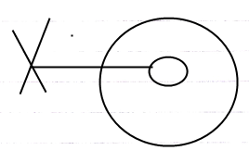

But that looks more like it can’t be a reference, rather than it can’t be referenced.
The latter may be expressed more clearly by:

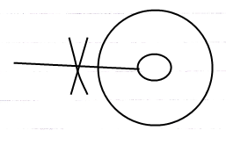

JJ

Visibility of Friends
Private members visible in the target definition and through references by friends.

If private members are visible only inside the target definition
AND through references by friends,
can this give a clue about how to express THAT objects are friends...

Other Ideas
If you do not see any access connectors,
do you assume, that everything is accessible,
or that nothing is accessible?
That is a good question for the display of access connectors.
But not essential to cover.

Questions:
- Can you make it an option to only show befriended commands inside an object, instead of friend and non-friend commands.

I am not sure yet. It is not clear.

Next to this friendship concept, the Black Box articles should also show the notation of Public and Private. I forgot about that. Those are fundamental for friend to make any sense.

Actually, conceptually it is completely clear to me now.
But the diagram notation is not clear yet.
I know the general notation of public and private, only private used to be expressed as inaccessible from outside the object… from outside the FRIEND object, that is.
Indeed.
Hmmm… and what if … the friend object is out of sight. or displayed as a sub object of the command / a parameter of the command. How with an access connector do you express that the the object has access to the command’s private contents (so the inverted view… work that out).

So there is a lot to work out about the diagram notation.

The whole original notation of public and private does not work anymore.
Because private was expressed as not accessible from the outside..
but that does not make sense anymore.

It is accessible from the outside... if the outside is a friend...
So the notation has to be rethought through once the conceptual point of view
is finished.

The notation is not very well usable yet to clarify the concept. So that sucks a little for now.

Private expressed as accessible from the inside might make sense
if the friend objects are displayed inside the parent object.
But from a more loose display of friends it is not the whole story to
private: it does not mean accessible only on the inside.

Private & Public,
2008-06-10

Notation:

The public members are displayed with
lines going out of the parent object,
with an access symbol attached to it.
The private members have no such
line going out of the parent object.

When a member is accessible as an object,
class or interface, this is a solid line,
when a member is accessible only as a class,
this is a dashed line,
when a member is accessible only as an interface,
this is a dotted line.

JJ

Private & Public,
2008-06-10

Editing definition:

> 2009-06-30 Some of the ideas here are wrong, but the general idea should be thought of about editing the definition.
Friend access is different from access to private contents
only when editing the definition.
> 2009-06-26: No. this is user access control. Some users are authors of a definition. Some are not. Do not confuse it with private/public concepts.
It's the difference between friend for reference,
and friend for change.
> 2009-06-26: Bull, see last comments.

If you are a friend for change (not for reference) for private contents,
you will only see the private contents if you are at logical target the definition.

JJ

- Diagram notation of those accessible and inaccessible

… and shows for instance, that private stuff is mostly only visible in a definition, and not in a call or object.

Friend notation
2009-07-01,

Friend declaration. Friend access. Friend access connector.

JJ

The ‘accessible on the inside’ notation of private works only in the containment view, but not in the referential view. The ‘inaccessible from the outside’ notation of private works for both views.

Miscellaneous Issues

Deeper Exclusion
Apart from controlling access to the type’s own procedures, a type can also control publicity of procedures of its chilren. That way you can publish a child, but make some of its public procedures inaccessible outside the parent. This way you can also exclude members of a base type. A parent can’t make a child’s procedure inaccessible to the child itself; it’s the child’s own procedures.

You can also exclude members of ancestors even further down the hierarchy.

Forms of exclusion other than Private are just called exclusion or privatising.

You can only make a procedure of a child less accesible, never more accessible. The parent can’t publish a child’s procedure that the child defines as Private. A child can’t put restrictions on how its members are privatised by the parent, so a parent has full control over the exclusion of the procedures its ancestors.

Exclusion access controllers are also called access modifiers, because they modify formerly set access controllers.

Inheritance, Exclusion,
2008-10-15

This is also a blackboxing thing...
... but I put it in inheritance.

JJ

Inheritance, Exclusion,
2008-10-15

Because it is complexity hiding,
it is blackboxing.

JJ

Exclusion,
20008-10-16

But it is just access control,
so it is blackboxing, not inheritance.

You can apply access control combined with inheritance, to further specialize a class, object or system.

JJ

Exclusion... so a grandparent imposing extra access control onto its grandchildren...
Another advanced topic to cover at the end.

Gee, Public and Private are already a form of exclusion,
because the parent object is imposing restrictions to access
to its sub-objects ( the references it contains. )

When you make it private, it means that it is only accessible to friends...
hmmm...

Deeper exclusion protects members of sub-objects,
but how much can those sub-object members be protected, if they might
also be referenced elsewhere. Somehow they have to be protected from
being referenced elsewhere... fixed logical residence?
What if you reference the object from elsewhere?
Somehow it needs to be controlled, that an object is always referenced
THROUGH the object that protects it...
There is a link with user access control here, but I won't go there yet.

Yeah, there is a discrepancy between controlling access and the fact that
containment is now a volatile thing. Fixed containment needs to be
imposed in order to establish access control...

Multiple objects can impose another access modifier upon the same object,
so where are all these access modifiers stored?
At first it will only be access modification of a direct reference,
which is already under control of the parent object.
But for deeper objects it is different...
so I am not sure yet... are those deeper objects supposed to
be exclusively contained by the grandparent object?
Or can they also be referenced elsewhere,
so that the grandparent has to remember the grandchild access modification
settings and not just delegate that to the child, that holds the grandchild?
I'm not sure.
Perhaps details like that should be worked out when actually turning
this language into an actual programming environment...
and we should keep the focus on the general idea?

Private, Public is exclusion

< Public and Private are an application of exclusion. So then the base of the explanations can be only accessible and inaccessible. >

Protected
There is another basic access controller in addition to Accessible and Inaccessible: Protected.


Protected (By the way: it’s not an arrow.)

When a procedure is Protected, it means that it’s inaccessible if contained in a circle, but accessible if contained in a triangle.

 | ≈ | 
 | ≈ | 

A circular descendant automatically privatises a Protected member:

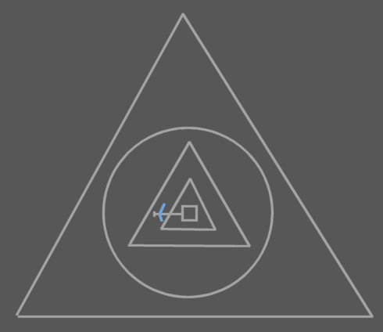 | ≈ | 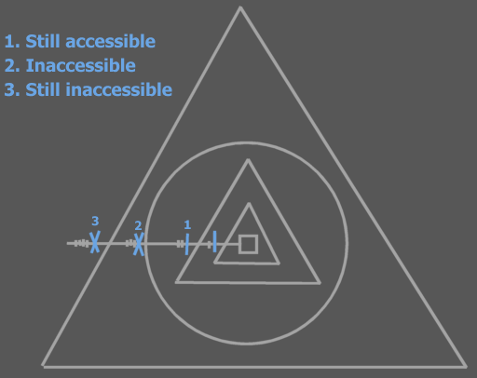

The member isn’t accessible to any higher symbols than the first circular descendant.

Formally the choice of making an extra Protected access controller seems totally arbitrary. In practice there are situations in which it’s useful to work with members that can be accessible to the interface holder, but not accessible to the outside.

Protected is used in exclusion only. It can not be used for ‘outcommenting’ code.

A triangular mark:



Is used to indicate that a symbol that owns the line is Protected, meaning, that it is only accessible when the symbol that owns the line is a triangle. A triangular mark is not an arrow.

And then there is Protected. A funny one there. It should be an extra issue, explained after everything else is explained, because it works the same way, except that the befriended object should be referenced with a triangle / should be the friend object’s base object.

Private & Public,
2008-06-10

Protected:

Something needs to be done with protected.

JJ

Friend in VB6
<< I have to note the application of the Visual Basic Friend access modifier. The basic access controller Friend isn’t required (Public Friend and Protected Friend). Friend Basic Access Controller means that you make a procedure’s own globality a Friend globality.

Yes, but for the effect of the Visual Basic Friend access modifier you also need to deprive global members from being accessed outside the globality. And that is done with globality level restriction.

So the effect of the Visual Basic Friend access controller is replaced by • making the globality a friend of the procedure and level restricting global procedures.

NO! It’s just making it Globality Up 1! Nothing Else! Do not use a Friend Globality for specific procedures!
>>

Friend for reference
Means access only anywhere within the globality, but not inside embedded globalities.
< 2008-10-10 That was the VB meaning of Friend. >

A procedure can contain variable objects. The public ones are parameters. The friend ones are parameters within the current globality.

< Old VB meaning of Friend >

< What place the VB6 keyword Friend has in black boxing, I do not know. this is a detail even less prominent, than Protected, which is also a detail later discussed. VB6 keyword friend has to do with access from within globalities. >

Objects Take Over Class Access Control
… is objects taking over friend relations from classes as straightforeward as you’d think?

Side-Issues

Private Names

Private Names,

A name being private, even though the reference is not.
It's a detail, but it is an issue.

It is important to separate the interface from the implementation.
The implementation is only visible in the target definition.
> 2009-06-26: And inside references of friends.

For execution control commands, you have to be able to hide the name of a symbol when you call it. So while the symbol itself can be part of the interface, the name could be part of the implementation, which is not visible unless you’re editing the definition of something.

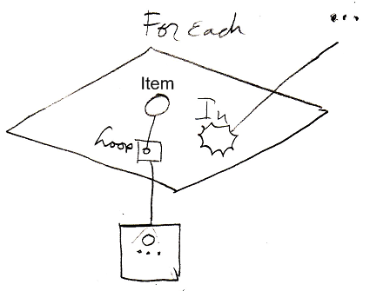
The cirlce inside the loop parameter is not named. It is an unnamed parameter, that might be referenced through the name of the variable it is pointing to. But I’m not sure about that.

JJ

Inclusion
Apart from a decisive access modifier, you can also give a procedure a suggested access modifier. This means that when you put an object in a type, a procedure of the object will get its suggested access modifier, for instance Private, but if its decisive access controller is Public, then you can still upgrade it to Public. This is called inclusion. The suggested access modifier is always set to less accessible than the decisive one. A type can also give suggested access modifiers to procedures of ancestors.

Black Boxing and User Access Control
Access control will be fully managed
by the access control module, even for
access controlling an object's members,
making the members only accessible
to the direct container of the member in
order to hide complexity from the outside,
or to to protect the object's data.

But that form of access control is so
important in programming software,
that it is introduced earlier
as the concept of Public & Private,
before access control is worked out
as a complete solution to security.

Maybe access controllers are a step into the direction of security. Maybe security should be a kind of advanced access control.

Interesting idea for user access control:
a constant in a program is a variable that can
be changed by a programmer, but not by a user
and also not by the program itself.

Public & Private,
± 2008-09

This project should be the working out
of the concept of Public & Private, even
before it is integrated into the complete
Access Control concept.

Public & Private need a preliminary notation,
and preliminary explanation, so that the concept
can be used in explanations of
coding concepts whereever required.

JJ

Programmers and Users
… = user access control

privates visible in friends, and in definitions when you have user access to it, so you are a programmer, not a user.

Something like that…

Details, Cover Last

Level Limitation
< Exclusion is restriction set by a container. Level restriction is like exclusion set by a child for the container. >

> 2009-06-27: I am not sure why I would need a child object to restrict the number of levels up it is accessible… why? for protection? Well… I would better resort to use access control for such protections…

Basic access controllers are decisive, but level limitation adds additional restriction.

Level limitation is paired with the basic access controller.

Pairing object level limitation with the Public access modifier, makes a procedure public only to limited number of levels up the ancestry.

Public Up 2

A procedure with this access modifier is accessible but two levels up the ancestry. Outside those levels, the procedure is inaccessible.

No object level limitation: Public
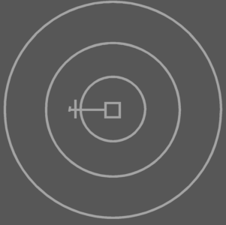 | ≈ | 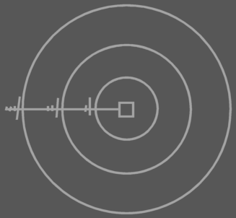
Object Level Limitation: Public Up 2
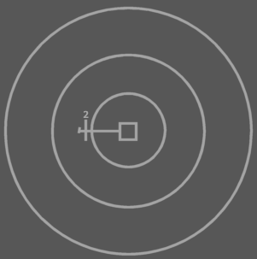 | ≈ | 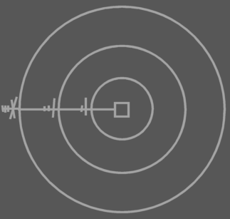

Level limitation works the same for the Protected access modifier, but gets the additional restriction that comes with that access modifier:

Protected Up 2

A procedure with this access modifier is accessible two levels up the ancestry, but inaccessible outside the first circular descendant.

Protected Up 2, contained in three triangles
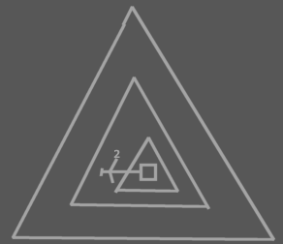 | ≈ | 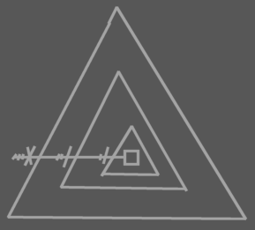
Protected Up 2, contained in a triangle contained in two circles
 | ≈ | 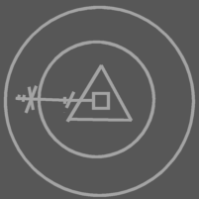
Protected Up 2, contained in three circles
 | ≈ | 

Level limitation can also be applied to deeper exclusion than Public and Protected. So a parent can impose level limitation on a child procedure.

Level limitation on deeper exclusion
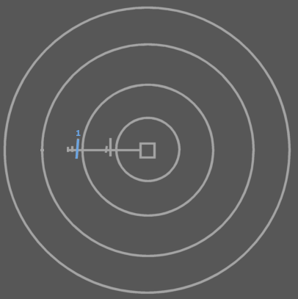 | ≈ | 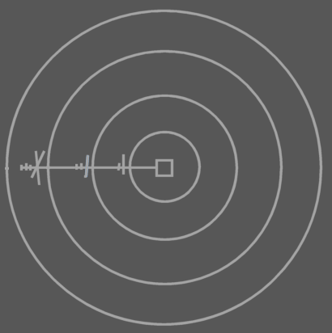

You can also apply level limitation for on symbols shalower than the target procedure.

Level limitation on deeper exclusion
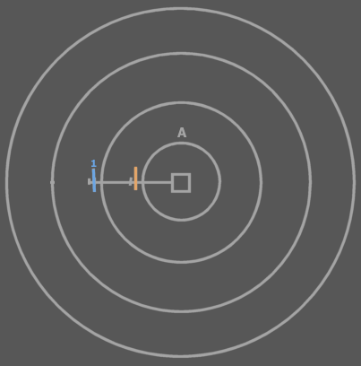 | ≈ | 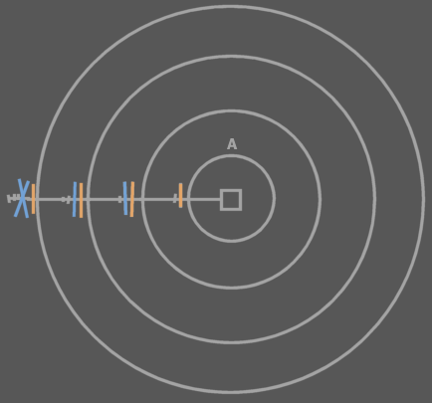

Level limitation is defined there where it doesn’t have effect yet. It only has effect higher in the ancestry. Basic exclusion is always defined there where it has effect. So level limitation automatically excludes members at n levels up the ancestry.

< Figure out a better diagram notation. >

Maybe call it Level Restriction.

Globality Level Limitation
<Pictures>
Apart from object level limitation there is also globality level limitation.

Public Globality Up 1

When an access modifier is paired with a globality level limitation, the access modifier works normally n level up the globality ancestry. But for higher globalities the member is inaccessible.

Public
 | ≈ | 
Public Globality Up 1
 | ≈ | 
Public Globality Up 2
 | ≈ | 

Protected Globality Up N works the same as Public, but adds the extra restriction that comes with protected.

> 2009-06-27: Globality level limitation is that VB6 Friend idea. That is probably why I also introduced object level limitation to begin with: as a bridge towards the concept globality level limitation. It is more like overkill… I do not know yet how VB6 Friend access is supposed to look, but perhaps you’d better just appoint inside which globality you still have access to it or something, instead of coming up with Object level limitation and only to build globality level limitation only to have a substitute for VB6 friend access control.
> 2009-06-29: But level limitation and then globality level limitation is a lot of systematics to introduce just to facilitate a VB Friend access modifier.

<Pictures with that? >

<‘Globality Up 2’ is too long, because Public Globality Up 1 will be used commonly. Visual Basic’s Friend access modifier is the same as Public Globality Up 1. I might need to invent a specific term for Public Globality Up 1. I won’t use ‘Friend’, because that would conflict with >

Access Controlling Globals
> This issue is more important than level limitation and globality level limitation, but those two concepts are used in the implementation as laid out below (the implementation will probably change in the future.

Access modifiers in Globalities:

- Global Inaccessible
- Global Private
- Global Public

To understand what happens when procedures inside globalities are given access controllers you need to view the globality as an object, that is referenced from any of its ancestor objects:

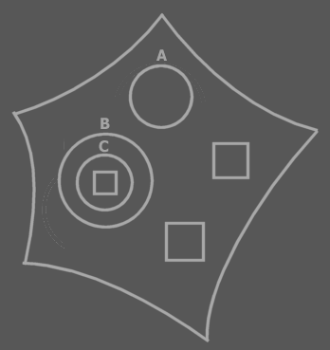 | ≈ | 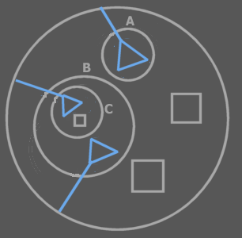

If a global procedure is Inaccessible, it’s just not accessible at all (‘outcommented’), so not really global either. If a global procedure is Private, it’s not really global either, only accessible by the globality object itself, just like something private of a circle object. If a global procedure is Public, then it is global. It is then accessible from any ancestor within the globality.

When a global procedure is Public it is however also accessible outside the globality, as a public procedure of the globality object. For a procedure to be global inside the globality, but not accessible outside the globality you use globality level limitation: Public Globality Up 1.

> 2009-06-27: And here I am attempting to differentiate between VB6 Friend on a global level and VB6 Public on a global level. I am trying too hard to make a match between access modifiers I know from VB6 and C++ and match them with a new language. I was too afraid to reinvent each atypical concept, and insisted to put those concepts inside a single systematic. That is why I went to such an extent with this level limitation stuff. Ok, I can respect it now. It is an attempt to put those access modifier situations into context, but I think this should only be an intermediate implementation of it and in the near future an easier approach needs to be come up with. This stuff here should be seen as just a brainstorm.

It is not a permitted to make a global procedure Protected. A pentagon is not exchangable with a triangle, so Global Protected wouldn’t have much meaning.
> 2009-06-29 That, by the way, is not true anymore. You can reference a globality triangularly if you want.

Access Modifiers in Globalities needs to be further thought through. It gets tricky as you put it in diagram code.

Access Control Presets

< Wat wel zo is is dat de standaard access control van system procedures er voor zorgt dat je niet zo maar rare dingen kan gaan doen. Erg belangrijk als je effe snel iets programmeerd, dat je de echt rare effecten uitsluit zonder extra moeite. >

< 2009-06-29 Bedoelde ik hier oorspronkelijk mee de macro-keywords voor access control? Zoals bijvoorbeeld Public Read-Only Value ofzo? >

<
I don’t have a special notation for publicity of Set procedures.
Set public or not is kind of like read only or not. Maybe I need a read only notation.

Write only is also common, though. For instance of procedure reference input parameters.
>

<Also cover constants>

When you give a system procedure an access controller, access to the procedure or object represented may get a special name and diagram notation.

An object symbol with an accessible State Read procedure, but no State Write, is called a Read Only Object.

An object symbol with only a Type Read, can be considered just a Type. Not an object or interface.

An object symbol with only an Interface Read, can be considered just an Interface. Not an object or type.

…
Etcetera, work it all out

Standaard access controllers
- Standaard zijn Add en Remove geblokkeerd. Zo zijn er nog meer dingen standaard geblokeerd
De klasse kan zelf initial access controllers aannemen die je ook weer kunt veranderen.

Something is constant if it can be set by programmers , but not by users.

< By default everything is public. When studying the access configuration of a symbol you might only want to see what differs from the default >

<The standard access modifiers for system procedures of procedure symbols directly inside a procedure symbol are different from procedures directly inside object symbols. For instance, Symbol Get for Reference of a clause is Private by default. Symbol Get for Reference for an object member is Public by default>

A call is by default private.

The access controllers of the procedure’s sub objects determine which purpose they serve. Maybe I should write a section about that in Access Control.

Required and Optional parameters as well as In, Out and Thru need to be rediscussed in Access Control, because it may be so that it is required for you to Object Set a parameter, while the procedure changes the state of the target
object. This is like thru too, but a totally different fashion and there are more ways of throughput.

If a configuration of any sort is a common one, it might be nice to make something like a typedef so you give the configuration a name of its own, Like if you commonly use ‘Public Up 1 Globality Up 2’, you might want to give it a different name.

Consider combining the concepts Presets, Macro-Keywords and just a brainstorm about nice-to-have keywords for common access control situations.

Best example: Public Read-Only Value. Read-Only Value.
You do not even have to introduce completely sound systematics, you can also just shed light on the general concept.

Those 'macro' access modifier keywords are not very important.

There may be an analogy between macro keywords and a C++ typedef.

(perhaps only for names)
( I think this issue was also temporarily put in the Parameters chapter originally.)

Details, May Not Cover

Access Modifier Get & Set
Interesting new system commands:
- Access Modifier Get
- Access Modifier Set
So would each system commands have its own system command
controlling the access modifier?
But what modifies the access to the access modifier system commands?
> Details...

Changing Access Modifiers at Run Time
Being able to change access modifiers at run time may be interesting. That way you can for instance change the interface of an object dependent on its settings. Changing a procedure’s access modifier is done by calling the procedure’s Access Modifier Set system procedure. There’s also an Access Modifier Get procedure to obtain the access modifier. This adds two system procedures to a square:

Access Modifier:
Get and Set

The Access Modifier property procedures can be access controlled themselves, so that they can be made inaccessible, for instance when you don’t want to be able to change the access modifier at run time. The access modifiers of the Access Modifier property can’t be changed at run time themselves. In other words: the Access Controller property procedures don’t have an Access Controller property of their own. This complies with the rule: system procedures don’t have system procedures of their own.

A single procedure can have several access modifiers so there are multiple access modifiers to get and set. This would suggest that the Accesss Modifier property has a dimension. However, when you call the Access Modifier property, you return or set the access modifier imposed by the object you’re calling from. The object you’re calling from is a hidden argument to the Access Modifier property. The access modifiers aren’t really stored inside the procedure, but in the object symbol that imposes it.

If the access modifier isn’t variable at run time, then the type defines a fixed access modifier. If the access modifier is variable at run time then the access modifier can be different for each instance of the type.

Changing ‘can be’ class, interface or object
System commands for changing access control to ‘can be’ class, interface or object.

Grouped Access Control
Using triangles to group members with equal acccess controllers. As with exclusion, the access controller of the triangle limits access again. It won’t make things more accessible.

Conditional Access Control
Replace the protected keyword by a concept like ‘when being a triangle’:
Basically you can optionally totally redefine the access for the case when the type is a used as a triangle.

<When being a globality?>

Or perhaps even make it as generall as ‘conditional access control’: Public if triangle.

Or perhaps I am looking too much for systematics behind it.

Delayed Creation of Object’s Privates
Public & Private,
2008-08-16

Perhaps for objects, private contents also only need to be created, when one of its friend commands is run.
>
But this is such an influential implication, that it needs to be covered elsewhere. Privates only make sense, when only a selection of commands, can access those privates.
So only when an object’s friend command is executed, the object’s private contents are needed.
But a sub-object’s system commands can also access privates…

JJ

Access Symbols And Accesses
< Just find an appropriate time to mention that each access symbol represents an access, but that it’s also used to denote direction, simply because direction can be read from it >

2009-06-28

It was realized too little, that each line crossing
is an access...

but in the automatic containment setting it is not.
The crossings of imaginary reference lines are not accesses.
The crossings of lines going from the imaginary reference to
the logical residence... I am not sure if those are active accesses.
They could be.
But this is more like an implementation detail....
Not important enough.

JJ

Maybe it's a good rule to only show access symbols to denote:

- Direction
- Exclusion of a procedure
- Denote explicitly the publicity

2009-06-28
- Each line that is crossed is a separate access.
That is probably why I wanted to have those extra ticks in expressing
access modifiers, but access modifiers and actual connections
are two different things. So the syntax of those two things is a different deal.
Whatever

JJ

Access Controller Parts
In one access controller you can use an exclusion access controller, an object level restriction and a globality level restriction:

- Protected Up 1 Globality Up 2

Access controllers as such are not usual, though and if you use them, they’re not very diverse.

> 2009-06-29: So basically this brainstorm item is about how an access controller can consist of different elements: each aspect is represented only once.

Other Details
< Give a story about the true meaning of an access symbol that denotes direction. That it is a syntactically correct access symbol. Access symbols can used to denote direction, because access symbols can point out direction.>

< A procedure’s primary access controller is only made Inaccessible to ‘outcomment’ code. This is a rather small concept. The rest of the use of Inaccessible and Accessible is in exclusion. Therefore, I need to denote in short that this is the only use of the primary access controller. I can basically always speak of access modifiers when talking about Accessible and Inaccessible. I can use the term exclusion in a lot of places where I now use ‘access control’. I also need to put the first section ‘Accessible and Inaccessible’ in the exclusion section. >

> 2009-06-26: I do not even know what I mean by this:
You will not be able to totally make clear what
private and friend means in this context,
but you can just use the term command anyway,
to make it clear.

< The word access modification can actually be replaced by ‘exclusion’ in many places, but not everywhere by far. >

Detail:
The symbols used here are actualy access symbols, which I’ve already introduced. Access symbols can denote direction, and they also denote where access takes place, but they’re also used to denote access control.

Interesting Applications of Exclusion
So examples of interesting applications of exclusion are:

- Making procedures Public or Private
- Excluding procedures of a public object
- Excluding procedures of a base object
- A parent’s controlling access to objects

Access to procedures is controlled. But access control usually defines which objects get access to them. In a special case you can control which specific procedures get access.

Out of Scope
Access Control,
2008-06-10

A user is also an object, that has private content,
that it can make public.

Every form of grant to access is given to an
object in the form of a virtual access card or ticket.
Tickets expire sooner than access cards.
The tickets and access cards form the access control
descriptor for what is accessible to an object.

An object describes what kind of options you have to
have on your card or ticket in order to get access.

Objects have their own security relations.
A user-object is an object with
certain access, but sees the objects' restrictions
to eachother. What's that about? How does that work?

JJ

Obsolete

About Exclusion
< A way to show access modifiers for deeper depths than 1 so access modifiers other than accessible, inaccessible, public or private >

Exclusion is the primary method for controlling which parties get access to a procedure.

A class controls which of its procedures are accessible to the outside (Public procedures), and which are not accessible to the outside (Private procedures). Private procedures are accessible to the inside the type.

> 2009-06-27: But only by commands that are friends of the object, which do not even have to be inside the object…

About Diagram Notation of Exclusion

Public and Private are notated as follows:

  Public |   Private

The reason that the following notation won’t do:

  Not Public |   Not Private

is that this access modifier is imposed by the procedure itself, not by its parent.

The reason that the following notation won’t do:

  Not Public |   Not Private

is that the access symbols in these diagrams are about access to the object, not access to the procedure of the object.

Each descendant that has access to the procedure can impose its own access modifier upon it.

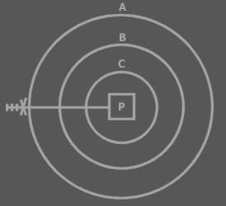

In this example A privatises P. The marks and the access controller are called an access controller list. The whole access controller list can be interpreted as a single symbol, which can be called the access symbol. An access controller can be placed on each mark. Each position in the access controller list represents the access modification of a deeper laid symbol. All access modifications are imposed by A. The first position modifies access to A itself,

> 2009-06-27: Actually, when you modify access to A itself, you should just create another line, attachted to A and access control it. Those extra ticks are not required at all.
> The extra ticks in exclusion access controllers in the Symbol documentation are not required, because the line itself suggests what is pointed at... The placement of the access controller does say something about which container access controls it.

the second position modifies access to B, the third position modifies access to C, thus the fourth position modifies access to P. The marks are called access marks, not to be confused with the term ‘access symbols’.

Very deep exclusion is uncommon, so you usually won’t interprent more than one or two access marks.

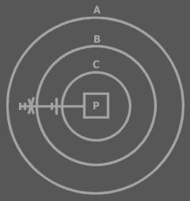

Privatisation is the last access modification. Once an descendant has excluded the member, higher descendants can’t exclude the member again, because they can’t access the member.

B has excluded P, so A can’t exclude P again. Both access symbols above are about access to P. The first position of the access controller list is always about access to the symbol that defines the access controller list. Not all positions of the access controller need to be displayed. The last positions can be left out at will. That means that the last access controller doesn’t have to be about the line target, but can be about an intermediate access.

Let’s cover how to interpret the examples I’ve already mentioned.

With these access modifiers, the procedure is making itself accessible or inaccessible.

With these access modifiers, the object is making itself accessible or inaccessible.
> 2009-06-27 And that is what I disagree with now. If the object was to make itself inaccessible, then the line should have ended at the object, not at the procedure.

This shows the access symbol for Public. The object is making the procedure accessible to the outside.

This shows the access symbol for Private. The object is making the procedure inaccessible to the outside. The procedure is accessible inside the object. You could denote this:



The extra access symbol denotes that the procedure makes itself accessible.
> 2009-06-27: I would give that its own line now…
The access symbol of the object makes the procedure inaccessible to the outside. Procedures are usually accessible to the object symbol they are directly contained in, so the extra access symbol is not really required.

> 2009-06-27: < start of useless story to tell >

A parent can’t make a child’s procedure inaccessible to the parent. The effect of this rejected concept is basically identical to giving the child its own abstract type: a derived type that excludes members of its base:

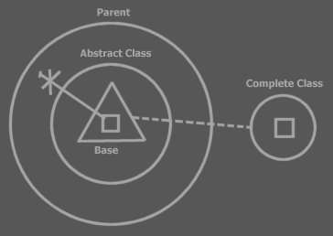

The parent contains a child object. The type of the child is defined right inside the parent: Abstract Type. The type is based on the complete type. The abstract type simply excludes a few members. You don’t always need to show the excluded members. In some views you will only see the published members:

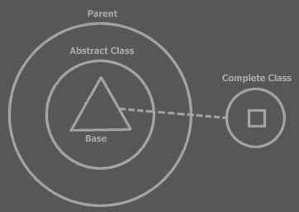

> 2009-06-27: < end of useless story to tell >

A Procedure’s Set of Access Controllers

> 2009-06-27: < start of another useless story to tell >

Exclusion adds a whole set of access modifiers to a single procedure.

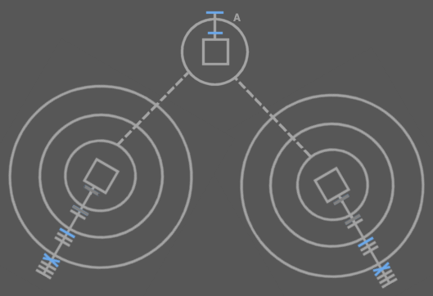

The access symbols in blue are the procedure’s access controllers. The dark grey access symbols are also the procedure’s access controllers, but these were already defined in type A. You can see that in any other type that uses an object of type A, a new set of access modifiers can be imposed. You see that each access controller of the single procedure is shown at a different symbol. The access modifier for a procedure is shown close to the type that imposes the modifier.

> 2009-06-27: < end of another useless story to tell >

Constants (Brainstorm)
<oops the following text can not be put in the introduction>

Design Time Set and Design Time Copy are actually called at run time, because nothing is set at design time. Design Time Set, though, can only be called in the Create procedure of the closest mutual descendant. Actually, a set in the create procedure is actually a call to the Design Time Set and Design Time Copy.

The initialization of constants happens in the Create procedure of the mutual descendant. < <OR THE one that defines that the set is only for design time?> Explaining that would require knowledge of exclusion.>

Other
Only types can be befriended. Friends can be both types and separate procedures.
> 2009-06-28: This is not required in the new setting. A command can also be befriended, making its privates accessible, but I am not sure how useful that will be, though, or even possible when privates of commands have delayed creation.

< So you can choose to give friends access to all private members or, another method, which requires a different syntax, allows you to make a selection of private things public to friends. >
> 2009-06-29: Obsolete, because that was the friend method concept, which is replaced by befriending an object with a command object.

Er moet access control zijn voor het stellen van lines, bijvoorbeeld naar de inhoud van een parent.

- Inside directly accessible, outside only 'indirectly' accessible (if line set FOR you)

Little disclaimer: I use the word Friend here, but it’s not the same as the Friend access controller. It’s a keyword overused here. However, it’s overused the same way in C++ and I have not yet come up with a decent alternative. The word Friend has been taken over from C++, just like the other access controller keywords. The access controller keywords aren’t super accurate description of their effect, they are just picked because the words are short and you can related their meaning remotely to their effect. I ain’t good at coming up with inaccurate names for something, so I can’t find an alternative now for this second hand use of the keyword Friend. I could go look for more concise words for the access controllers, but those would confuse me, because I’m still used to the old words. And it’s hard enough trying to get the description of this programming language on paper as it is.

Continguous dissector < | Friend for reference

Do Not Use
< Don’t say that procedures can’t be defined as inaccessible. They have to be definable as inaccessible or you’re not able to ‘comment out’ code. This also requires you to use the term access controllers more often. >

> 2009-06-28: don’t even mention this in the future. It is so trivial:

A line other than a call line can show access symbols, while there aren't really any access. These access symbols represent accesses made by the mutual descendant when it set the line. Accesses did occur on calls to the Set and Copy procedures of the source and target symbols when the line was set.

Access symbols are also used in a diagram only to indicate the access control. In that case there’s no question of an access either. Only of an access that might or might not occur.

<< … yes this is a section >>

Darn. What if you want to group members that are excluded. Then the parent adds a grouping to the child type. Oops this grouping is not part of the child type. Well.. it can’t be used then.

I can use this notation:



So Symbol…
Has put all of the language’s access controllers in one system and added extra useful systematics.

Automatic Changes when Editing Code
When you for instance use triangles to group members of an object, then the access modifiers need to change. When first you accessed something one capsule deep, is accessed two capsules deep when you put a triangle or circle around it. Access modifiers change accordingly when you edit code:

<P: Circle with public procedure >
<P: Trangle put around public procedure, changed access modifier>
<P: Circle with public procedure >
<P: Circle put around public procedure, changed access modifier>

You can’t always just put circles and triangles around everything. You might have to adjust access controllers, which are explained later. <Is that so?>

> First of all, in the newer notation, that does not have those access ticks, you do not really see the difference. Second of all, this is a detail, that will work itself out.

Other
Oh, optional parameters are initialized and then assigned the caller’s value. Where are those two steps performed.

Procedure primarily Inaccessible: This seems unuseful: why not just leave the procedure out completely? It could be used a means to temporarily deactivate code.

Private & Public,
2008-06-10

Do not use:

Next to public, private and who has access to it,
who can access the public and private contents.

If you have friend access to private contents,
you see it as though it was public contents.
> 2009-06-26: No: accessible contents.

JJ

